**ASSESSMENT 1**

Junit Test Suite for Banking Application

Overview: ABC bank is a highly complex banking application. The application handles multiple currencies, complex financial calculations, and real-time transaction processing.

Requirements: Java, Eclipse

Project Setup:

1. Open Eclipse IDE and create maven project.

2. Add JUnit dependency in pom.xml file

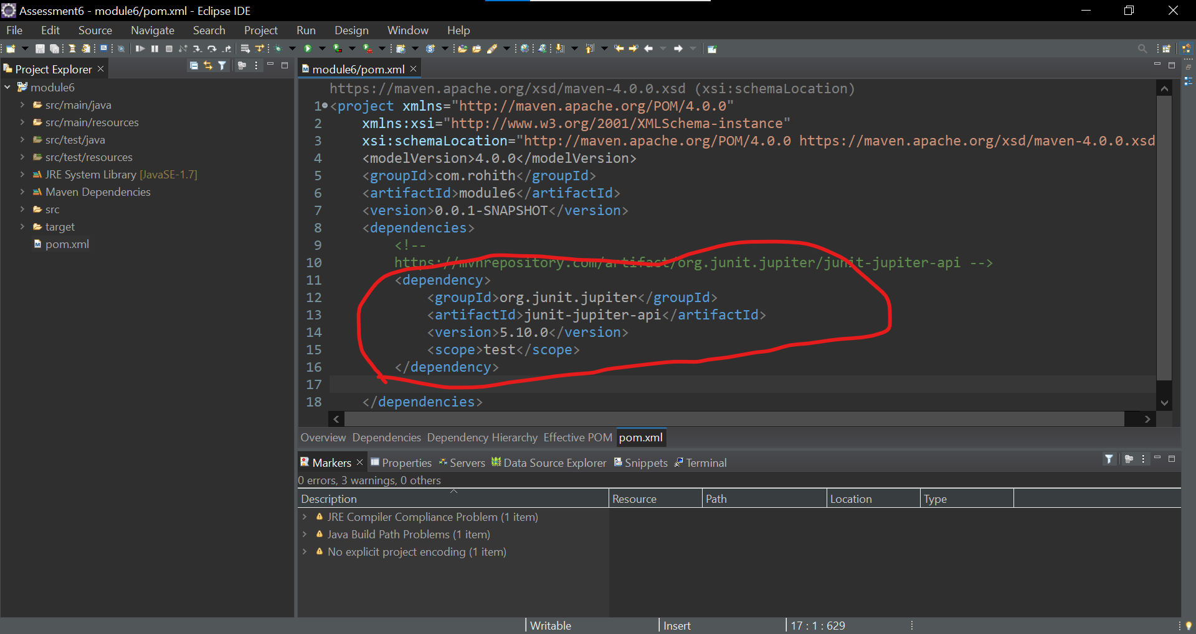

3. For production code create com.abc package in src/main/java and add classes there.

4. For Unit test code create com.abc package in src/test/java and add unit test cases there.

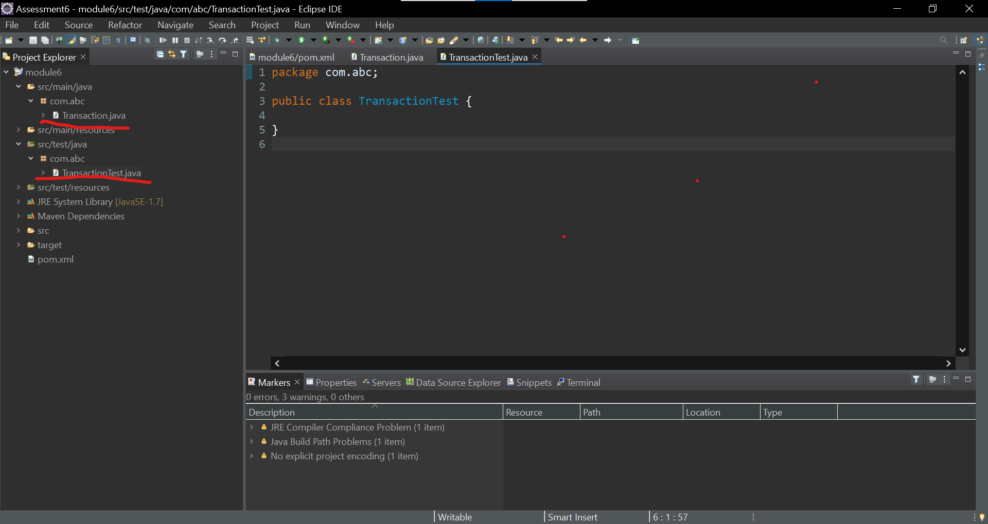

Basic code to mimic transactions

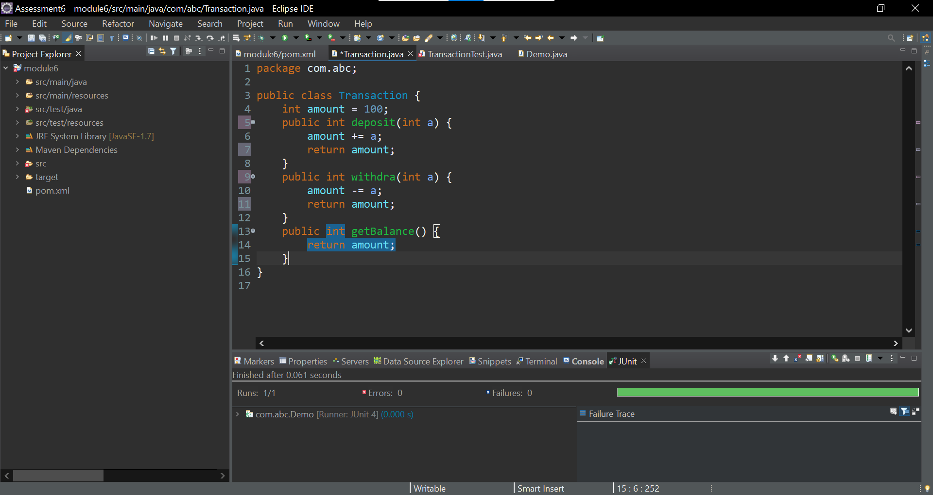

Below are some basic unit test cases written to test Transaction functionality.

package com.abc;

import static org.junit.Assert.*assertEquals*;

import static org.junit.Assert.*assertNotEquals*;

import org.junit.BeforeClass;

import org.junit.Test;

public class TransactionTest {

*@Test*

public void testDepositValid() {

Transaction t = new Transaction();

t.deposit(100);

*assertEquals*(200, t.getBalance());

}

*@Test*

public void testWithdraValid() {

Transaction t = new Transaction();

t.withdra(50);

*assertEquals*(50, t.getBalance());

}

*@Test*

public void testGetBalanceValid() {

Transaction t = new Transaction();

*assertEquals*(100, t.getBalance());

}

*@Test*

public void testDepositInValid() {

Transaction t = new Transaction();

t.deposit(100);

*assertNotEquals*(100, t.getBalance());

}

*@Test*

public void testWithdraInValid() {

Transaction t = new Transaction();

t.withdra(50);

*assertNotEquals*(100, t.getBalance());

}

*@Test*

public void testGetBalanceInValid() {

Transaction t = new Transaction();

*assertNotEquals*(200, t.getBalance());

}

}

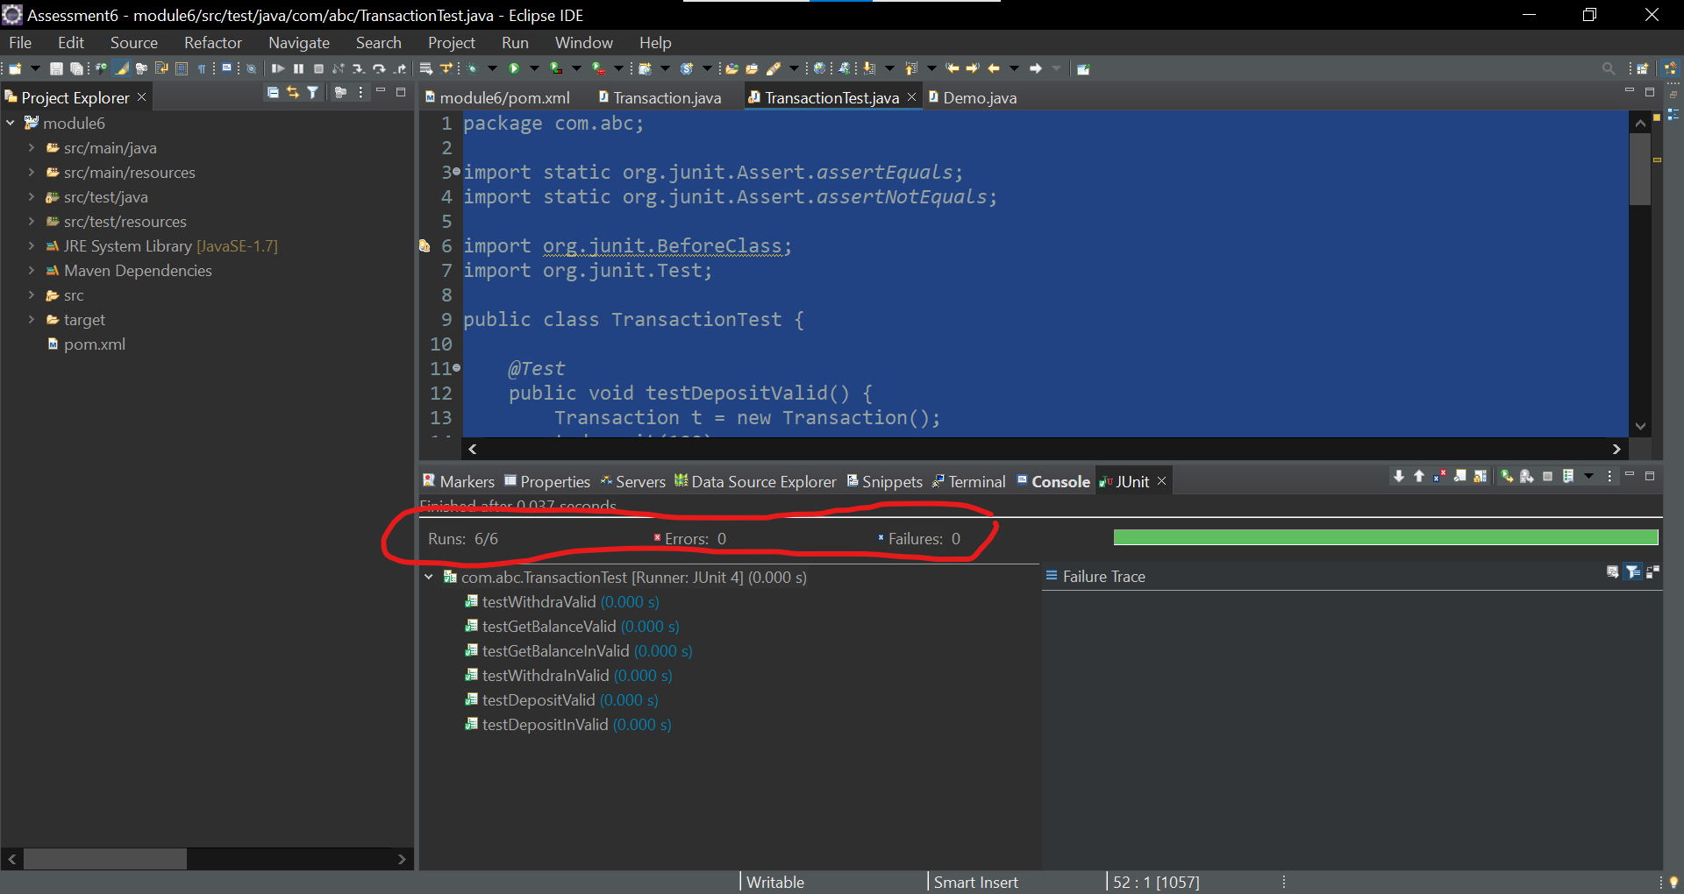

Successfully execution of all sample unit test cases.

* ABC banking application can achieve complex financial transactions with multiple currencies like INR, USD..
* Above mentioned sample test cases are examples for simulation real-time transactions.
* ABC banking application can handle large datasets containing historical transaction. We can test this functionality by performing stress testing.
* ABC banking application can handle multiple user request at a time. We can test this functionality by performing load testing.

**Submitted By:**

**Rohith Reddy**

**vrddam@amazon.com**